Student Name | YAHAYA DANJUMA ADDRA | Registration No. | C113/26/OCO/17001
Programme/Cohort | OCO/Cohort11 | Date | 18/09/2026
Instructor |  | Score | /100
Environment | Kali Linux / Ubuntu | Submission | E-Campus
LAB REORT ON BASH SCRIPTING
TASK 1 REPORT
EVIDENCE:
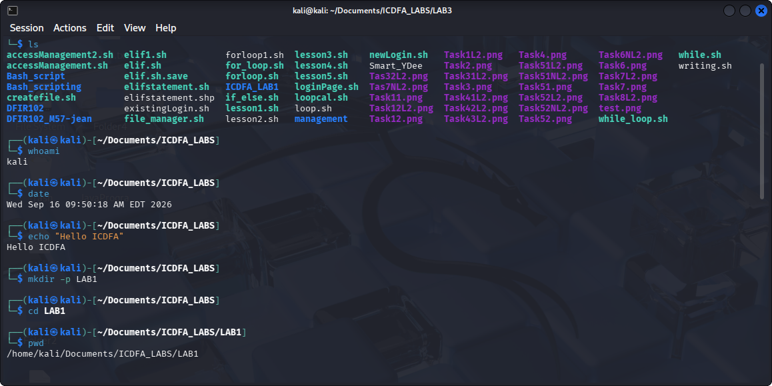
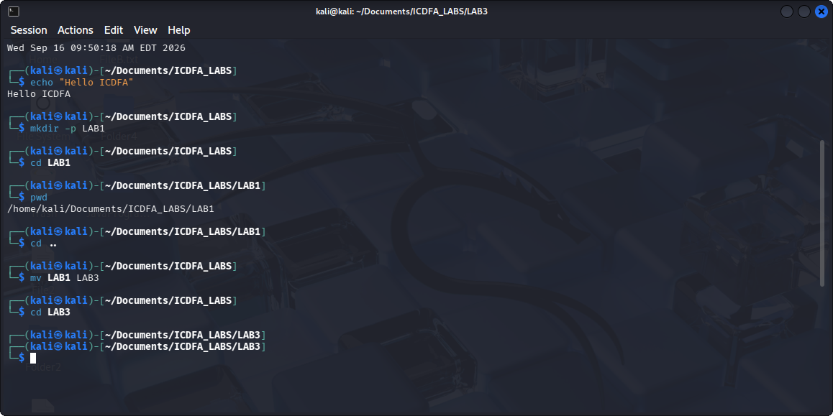

RESPONSE: Pwd shows the current directory I am working on.
I created a directory called LAB3 and ran cd command which took me to the newly created directory called LAB3.

TASK 2 REPORT
EVIDENCE:
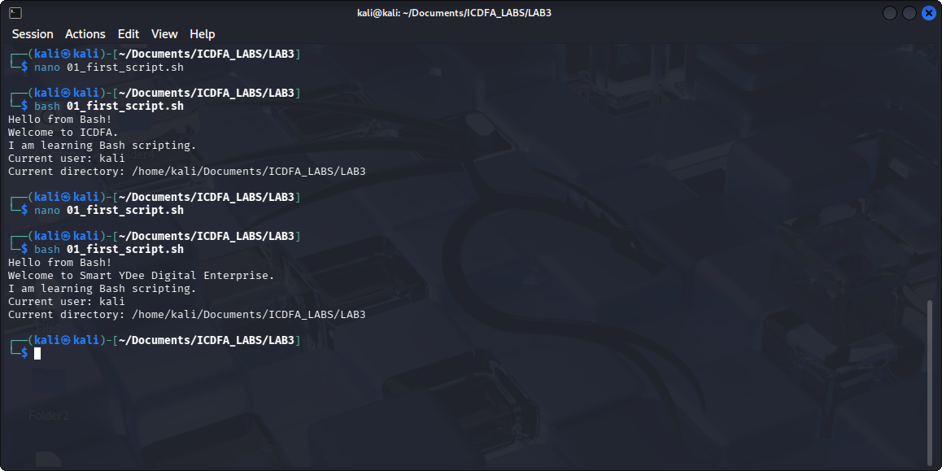
RESPONSE: In the script “echo” command displays the text, “whoami” shows the current user in the system, and “pwd” prints the current directory the user is working on.

TASK 3 REPORT
EVIDENCE:
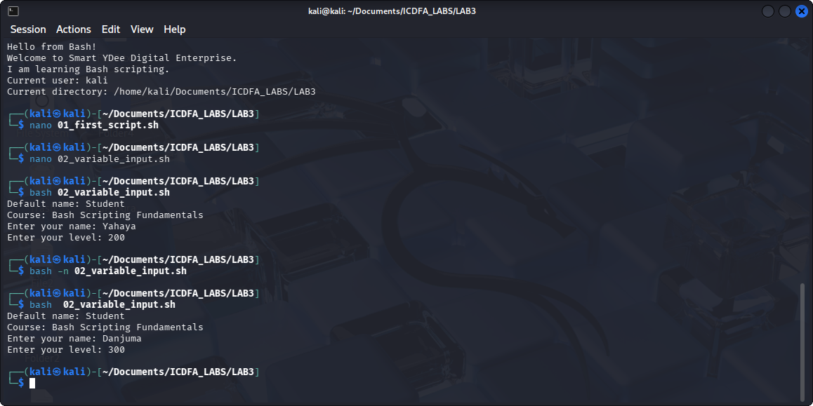
RESPONSE: In this lab –n checks if the syntax is written correctly, -z checks if the input is empty, || means logical OR, it is use to choose preference or to say either must be provided, exit 1, exits and returns the error that happened.
In summary this lab script collects input from the user. It uses –z which checks if the input field is empty and “exit 1” which exit and returns the error that occurred once the program fails, it exits.

TASK 4 REPORT
EVIDENCE:
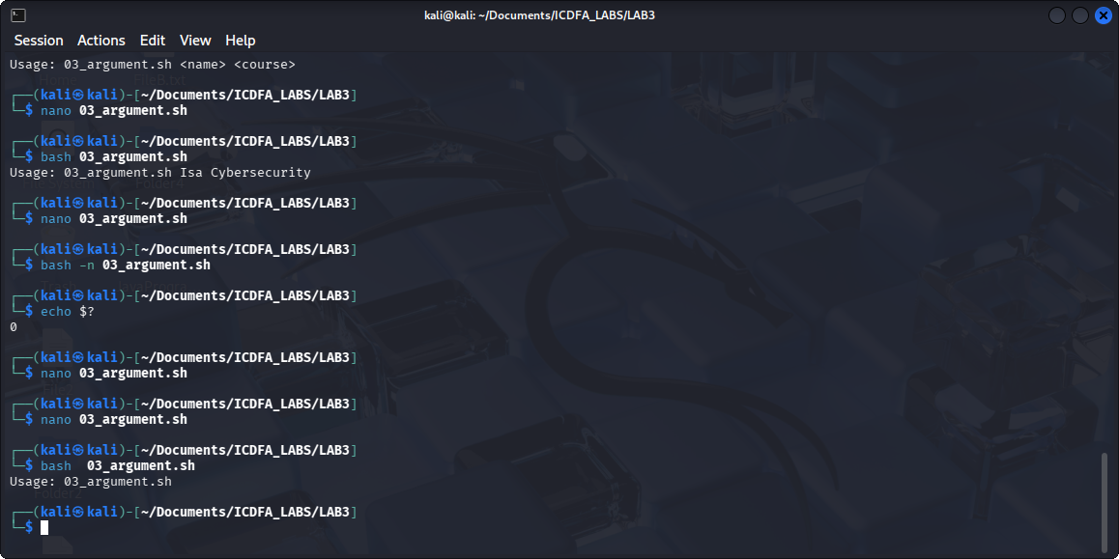
RESPONSE: In this lab, I have learned about arguments, conditional statement, and validation. The condition checks if the argument is ($#) less than 2 and then print script name ($0) and the items. If it fails it exits (exit 1) and return the reason to the user and if it ran successfully, exit 0 is

executed.
TASK 5 REPORT
EVIDENCE:
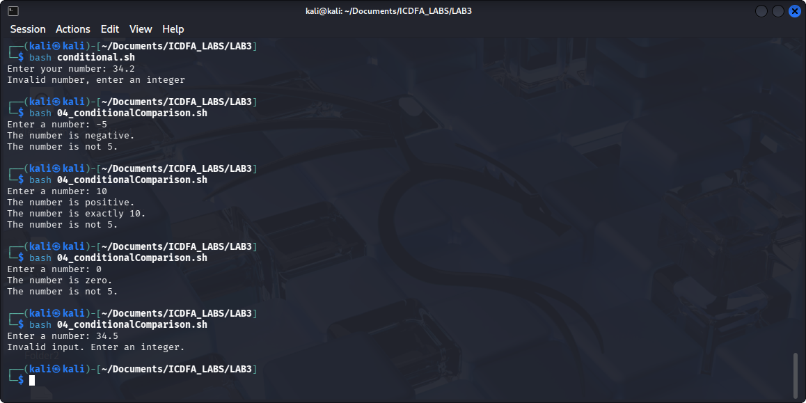
RESPONSE: This Lab script does compare and contrast with the condition to see if it matches or not. Like the condition if ! [[ “number” =~ ^-?[0-9]+$ ] checks if the number entered by the user is an integer, if not (!) it tell the user to enter and integer and exit immediately. Likewise, other conditions like not equal to 5, equals to 10, positive number, negative number etc.

TASK 6 REPORT
EVIDENCE:
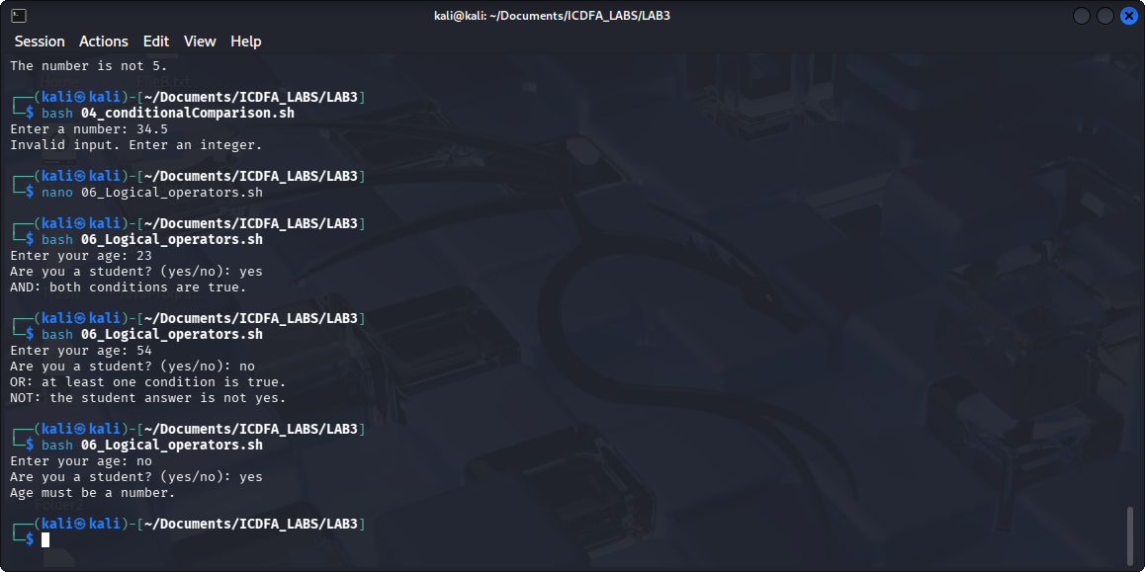
RESPONSE: This Lab uses logical operators to validate, compare, and check if a condition at least is met. It uses [[ "$age" =~ ^[0-9]+$ ]]; to validate if the age entered by the user is a number, || for at least condition is met, && if both conditions are met, and ! if condition is not met. This entails and enlightens me on how program logic works
TASK 7 REPORT
EVIDENCE:
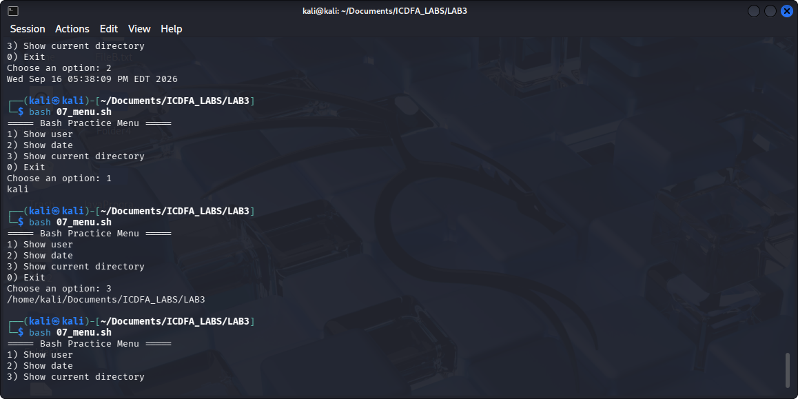
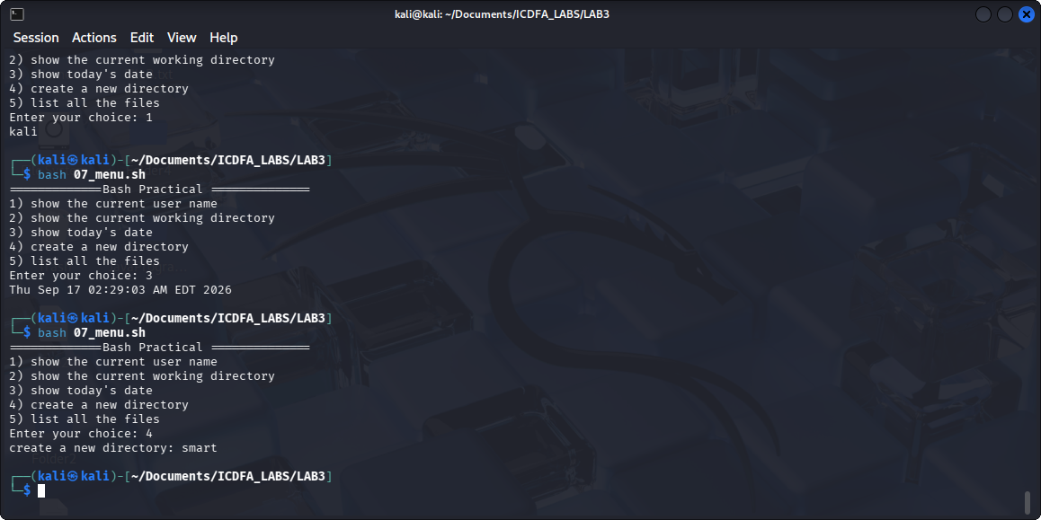
RESPONSE: This Lab contains scripts that allows the user to choose an option from a list, it executes the selected option and also if the user enters an option that is not provided, it will display “Invalid choice”.
TASK 8 REPORT
EVIDENCE:
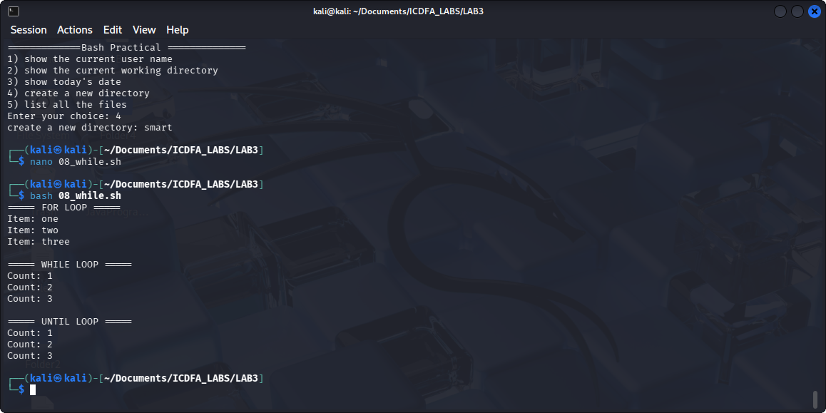
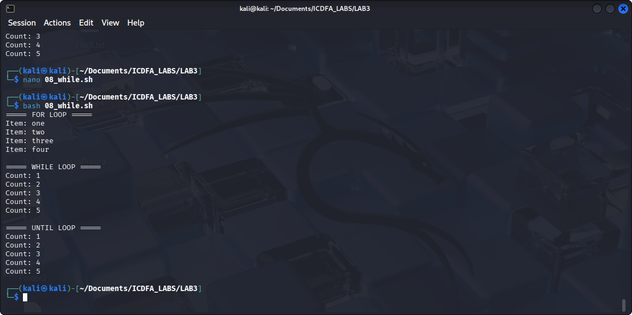
RESPONSE: This Lab script uses “for loop” for a number of known repeated task, “while loop” when the condition is met, and “until loop” when the condition turns false.

TASK 9 REPORT
EVIDENCE:
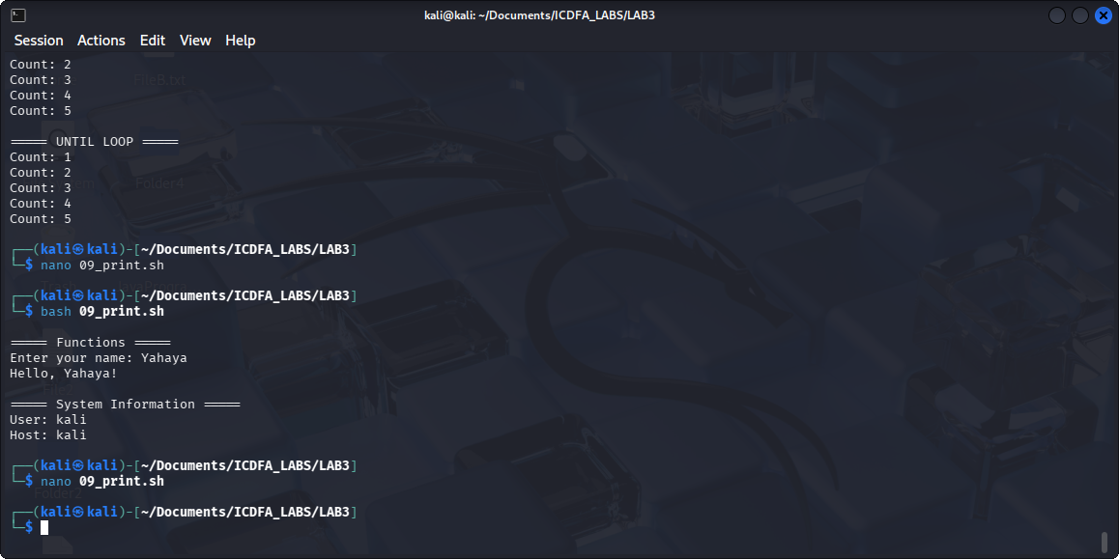
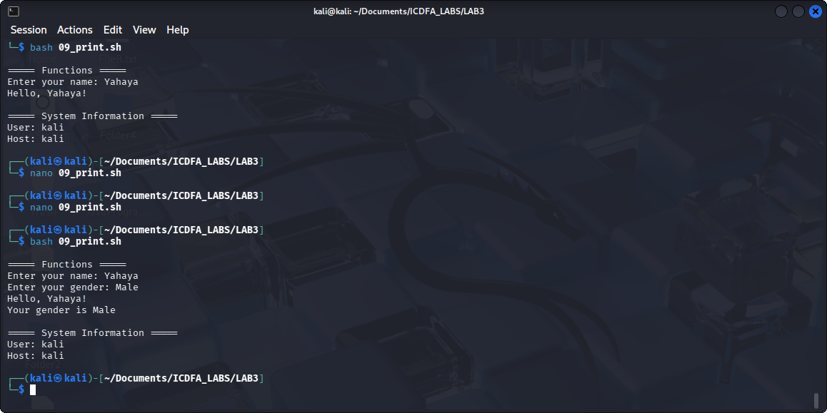
Print_heading function was created to return the first argument and it was called also to return the system information.
greet() greet and returns the first argument from the user input called name.
I created a function called welcome() which calls the first argument “your gender is $1”

TASK 10 REPORT
EVIDENCE:
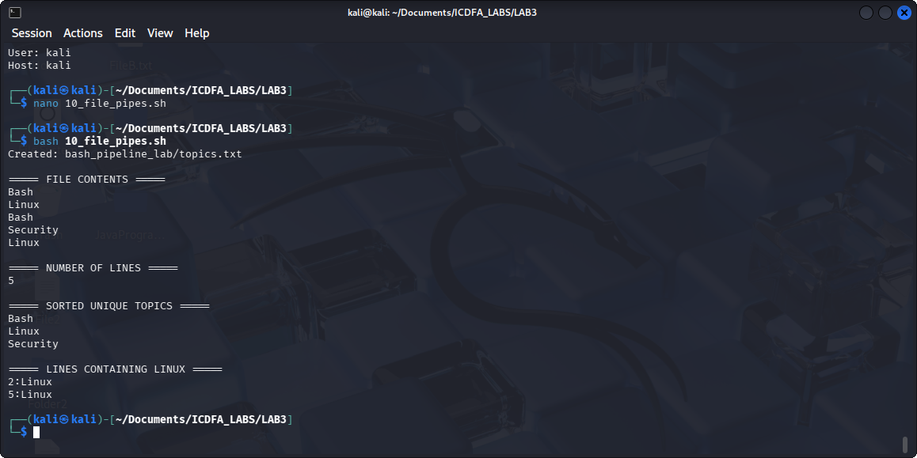
RESPONSE:
- > redirect text to a file. That is, whatever is created is pushed to the file
- | send the first command output to the second command as an input.
LAB EXPLANATION: This Lab particularly focuses on creating, redirecting, validating, sorting, and removing duplicate files. As demonstrated on the screenshot above, some files are created with the same names. What sort does is, it rearranges them alphabetically, uniq removes the duplicated copy in a sequence.

TASK 11 REPORT
EVIDENCE:
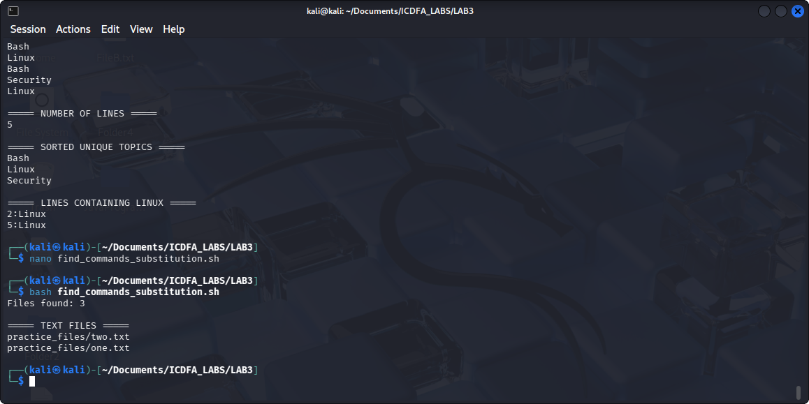
RESPONSE:
Creates a folder called practice_files.
Creates 3 files inside it.
Uses find to find the files.
Uses wc -l to count them.
Uses $(...) to store the count in the total variable.
Uses grep-like filtering with find -name "*.txt" to show only .txt files.

TASK 12 REPORT
EVIDENCE:
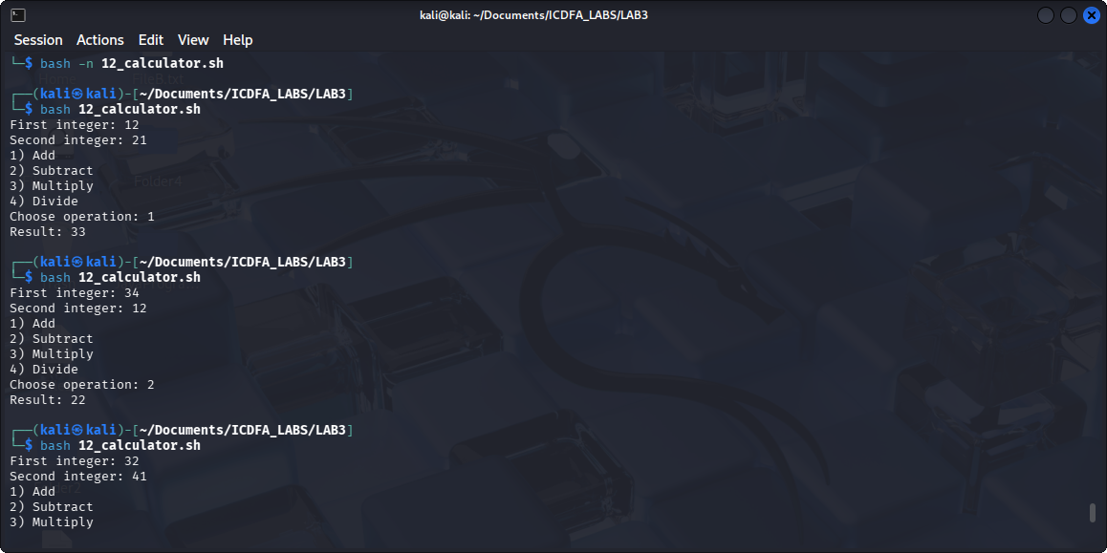
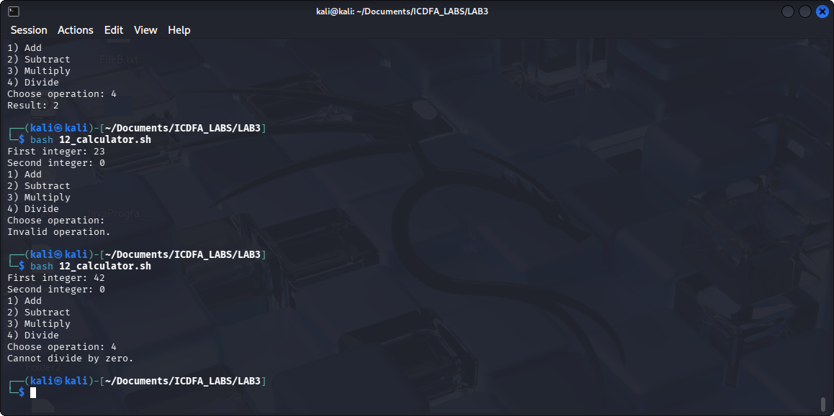
RESPONSE:
Asks for two numbers.
Checks that the user entered integers.
Shows a calculator menu.
Performs addition, subtraction, multiplication, or division.
Prevents division by zero.
Also adds Modulus as an extra operation.
TASK 13 REPORT
EVIDENCE:
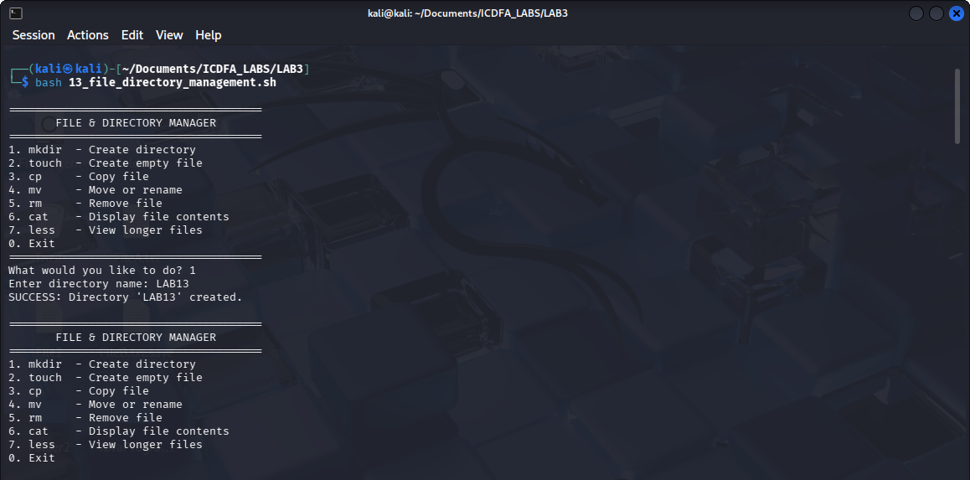
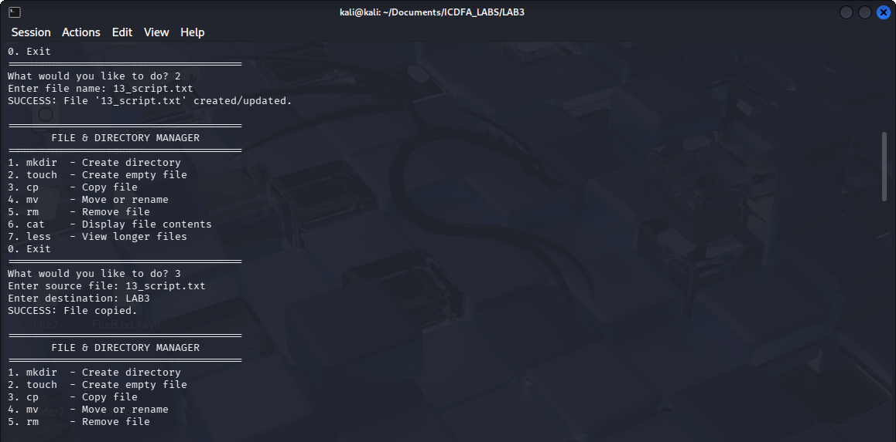
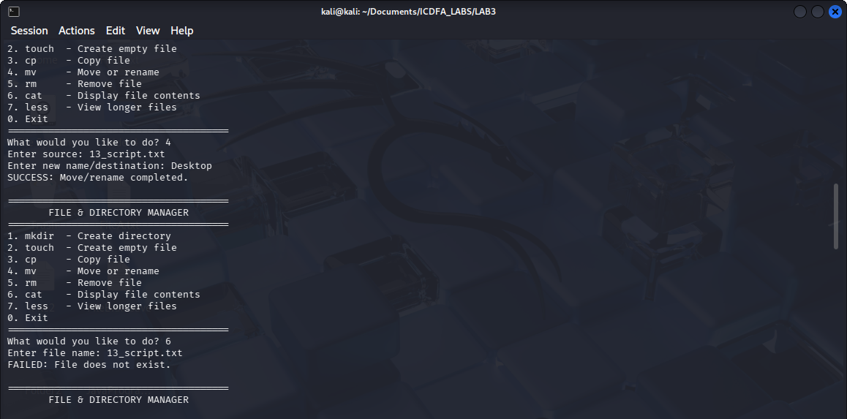
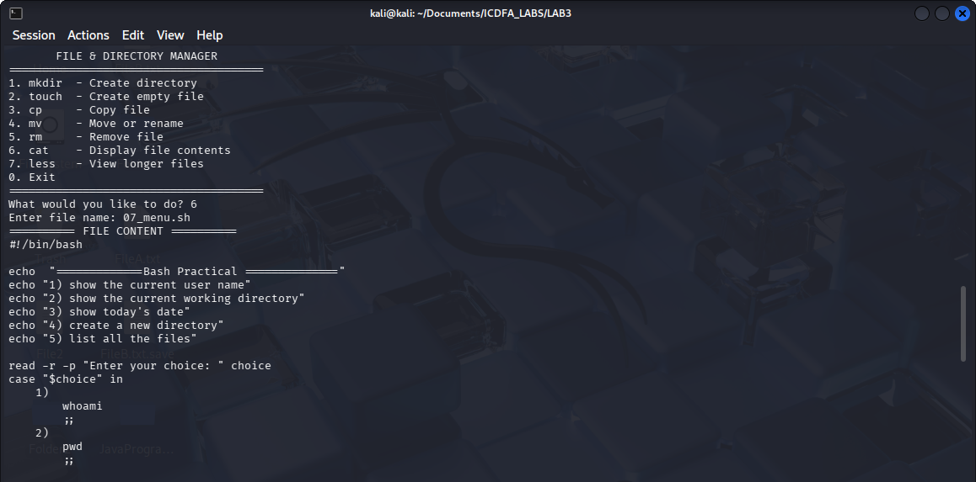
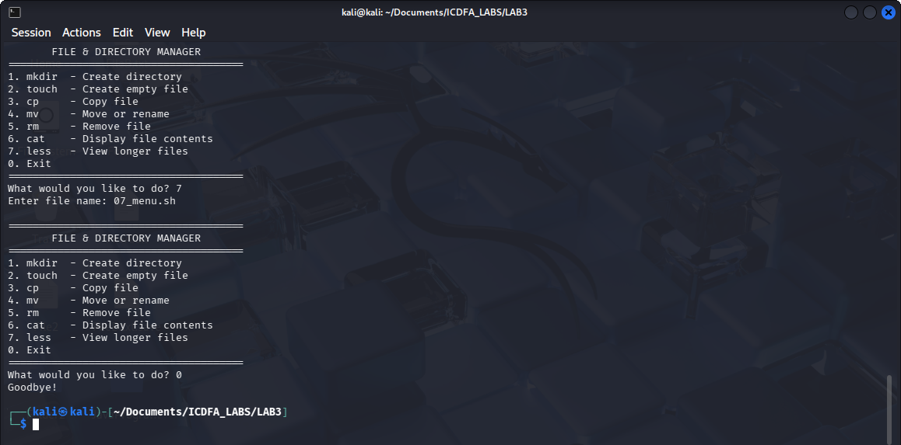
RESPONSE:
This script creates a menu that allows you to manage files and directories.
Mkdir: creates a directory.
Touch: creates a file.
Cp: copies a file.
Mv: moves or renames a file.
Rm: removes a file.
Cat: displays file contents.
Less: views a long file.
While: keeps the menu running.
Case: chooses an action based on the user's option.

TASK 14 REPORT
EVIDENCE:
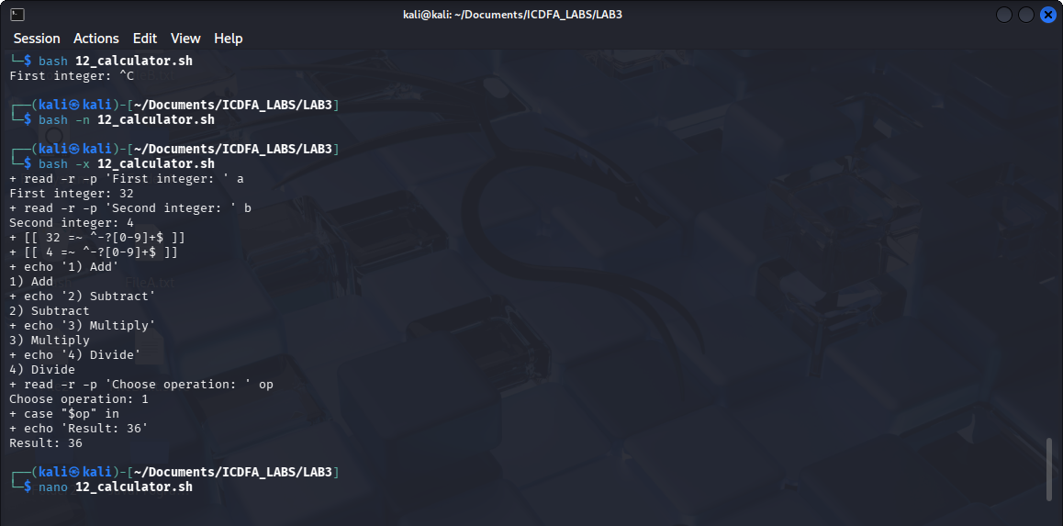
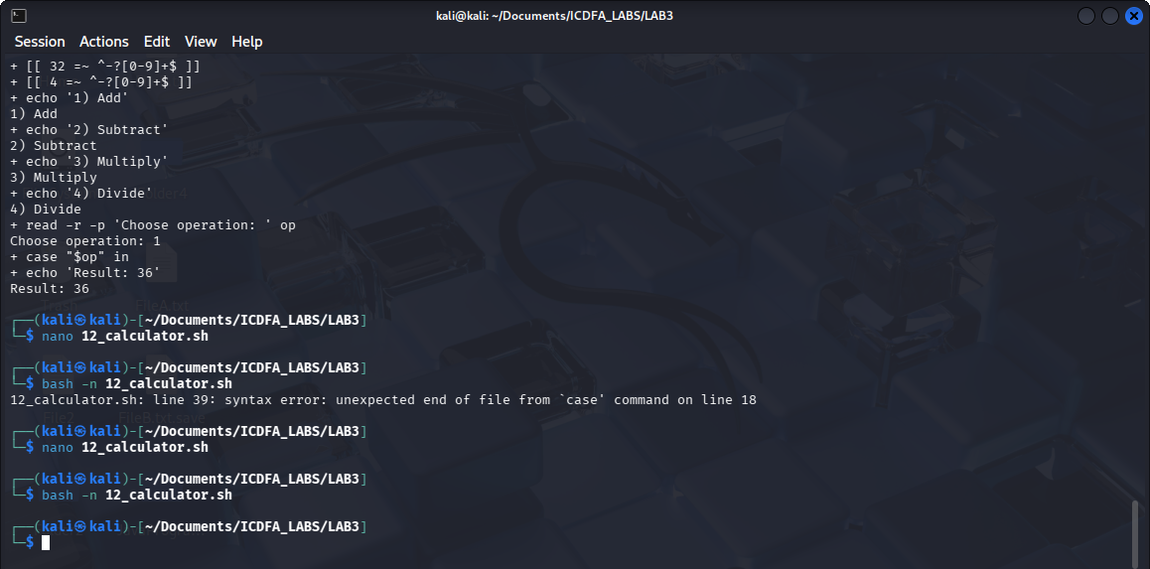
RESPONSE:
This lab teaches how to check and troubleshoot Bash scripts.
“bash -n script.sh” checks the script for syntax errors without running it.
“bash -x script.sh” runs the script and shows the commands Bash is executing.

TASK 15 REPORT
EVIDENCE:
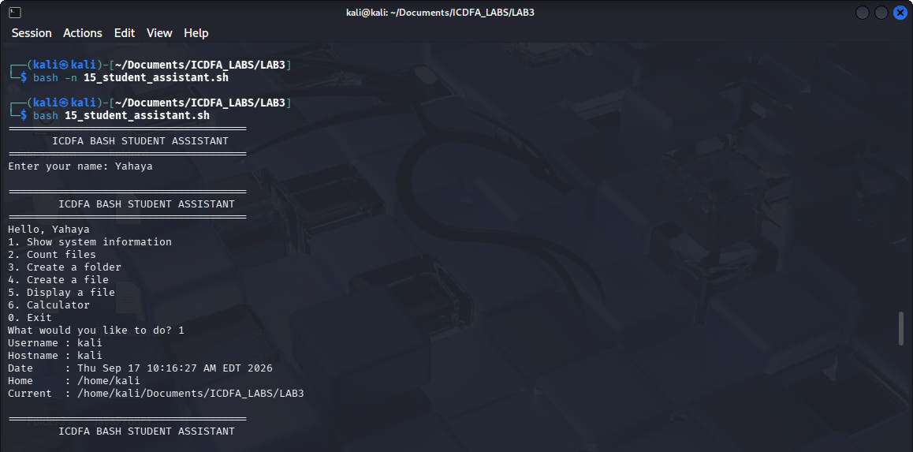
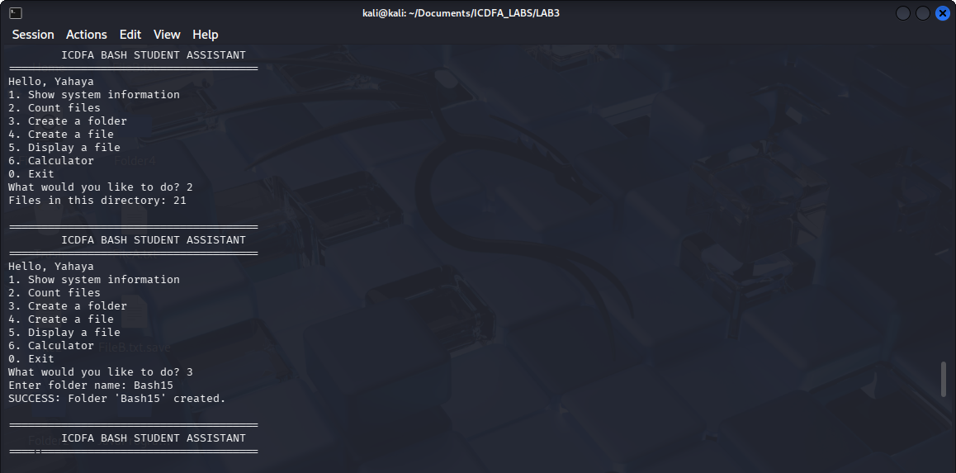
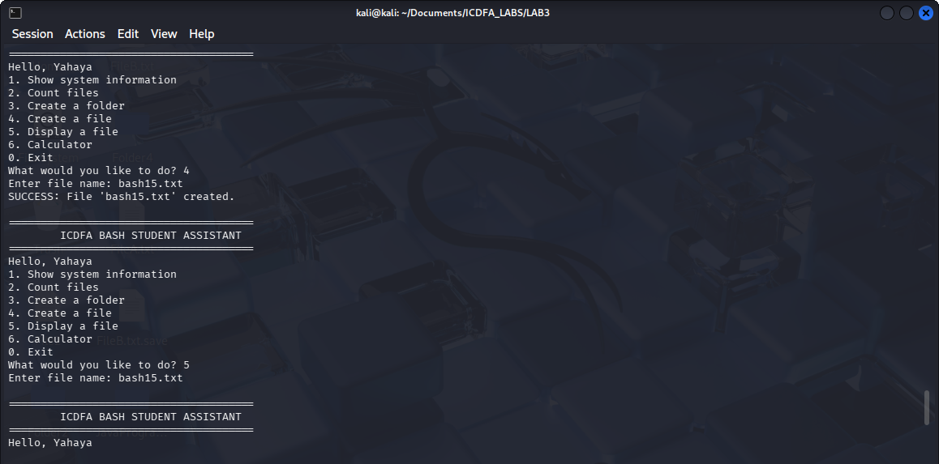
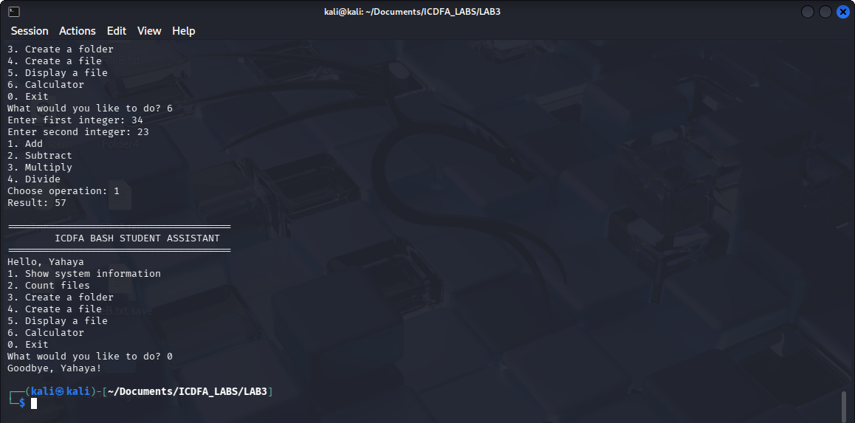
RESPONSE:
This lab teaches me how to combine different Bash concepts such as variables, functions, loops, conditions, and case statements to build a simple interactive command-line program.
The program allows me to perform basic tasks like checking system information, counting files, creating files/folders, viewing files, and using a calculator.

